LEARN KARATE
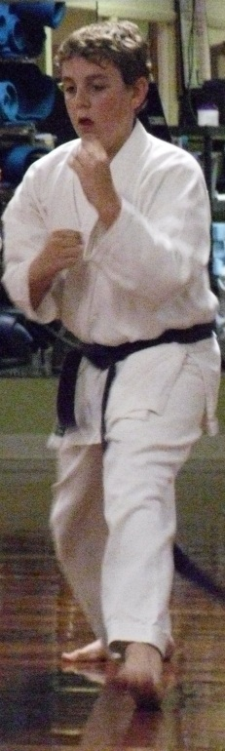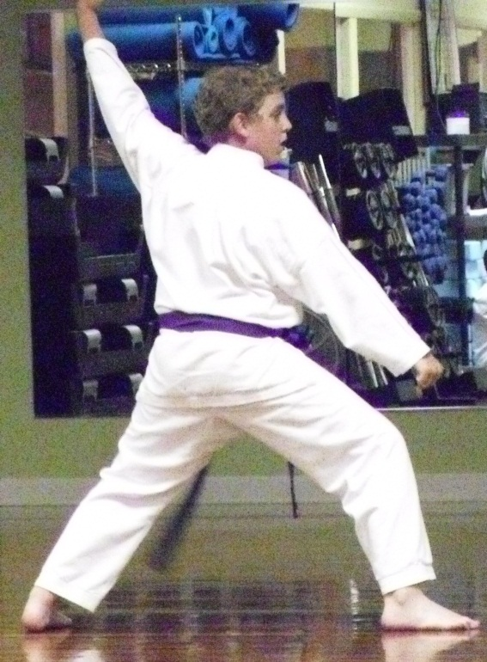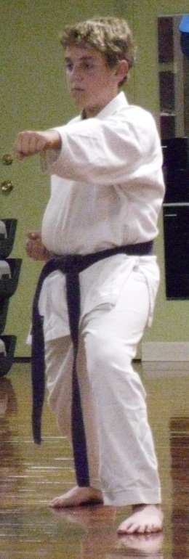
Ruben’s Karate Acadamy offers begining adn advanced classes fore youth and adults. classes focust on tecnique and stance, kata, and sparring.
- Increase musculer and arobic fitness
- Improve strength and and mental alertness
- Develop self-confidense, disipline, and sportsmanship
Sign Up Today! Call 555-3454.

