Foster Your Creativity
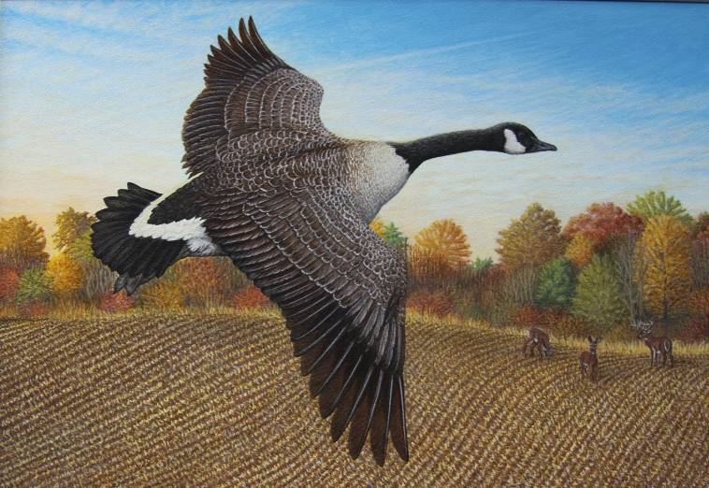
Take Painting Lessons!
- Small class sizes for all artist levels
- Personalized instruction
- Skilled instructors
- 10-week classes include all supplies
Bakersfield Art Studio at 15 Lake Street in Juniper
- Sign up online at www.bakersfield.com
or call Rob at 540-555-5500 to sign up!

