NEED AN ESCAPE?
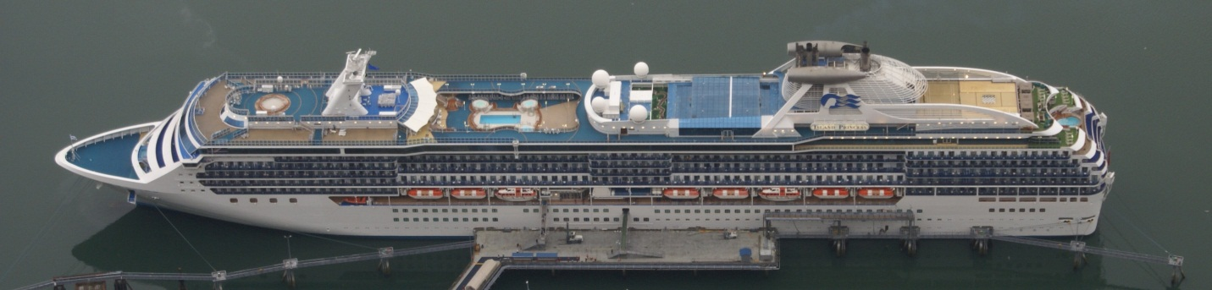
- Tango Vacation Club members receive a 10 percent discount for cruises booked during May. Select from a variety of destinations.
An experience of a lifetime awaits you!
- Ultimate relaxation
- Endless fun and entertainment
- Breathtaking scenery
- Friendly, attentive staff
- Clean facilities
Interested? Call TVC at 555-1029.

